BRITISH MEDICAL ACUPUNCTURE SOCIETY

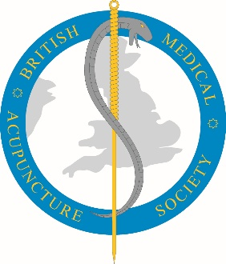

NOMINATION FORM TO SERVE ON BMAS COUNCIL

I (proposer’s name in full) …………………………………………………………

of (full address) ……………………………………………………………………....

……………………………………………………………………………………..…..

Signature of proposer……………………………..……….. Date ……………….

HEREBY NOMINATE

(nominee’s name in full) ……………………………………………………………

of (full address) ………………………………………………………………………

………………………………………………………………………………………....

TO BE A MEMBER OF THE COUNCIL AND TRUSTEE OF THE SOCIETY.

I agree to serve as a member of the Council and Trustee if elected.

Signature of nominee……………….……………..……….. Date ……………….

THIS FORM SHOULD BE RETURNED BY EMAIL
BY THE PROPOSER, COPIED TO THE NOMINEE, TO
london@thebmas.com
BY 13 APRIL 2025 AT THE LATEST

Note 1: Nominees are invited to email a short biographical note of not more than 175 words to the above email address. This will be included with the ballot paper.

Note 2: Where handwritten signatures are not possible, please type.

